**INSTALLATION AND WORKING**

1. Clone the repository into C:/xampp/htdocs/[“folder-name”].
2. Download xampp server from <https://www.apachefriends.org/download.html>

3. Install xampp server into the device.

4.Goto search and type “xampp control panel” and start the Apache and MySql server.

5.Open the web editor and type “localhost/[“folder-name”]/

6.If you are a member then press the “Sign In” button if you want to join then click the “Become a member” button and fill in the proper credentials.

7.You will now be redirected to the dashboard page.

 If u have some work you want done goto the POST page if you want to try your skills then goto the SEARCH page and continue on this  website.

A setup to the database:

1. Click on the admin button under MySql in the xampp control panel.

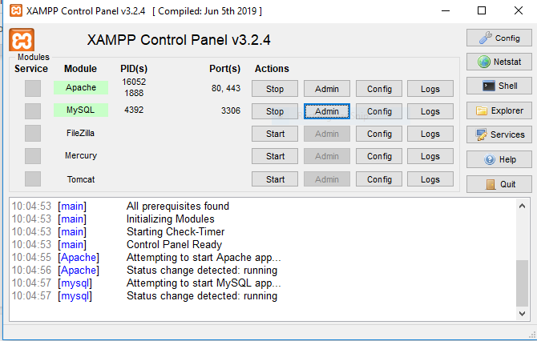

1. Now click on Databases and type the database name as “foodorder” and click the create button.

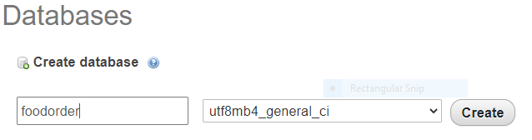

1. Now import foodorder.sql from C:/xampp/htdocs/[“folder-name”]/database/foodorder.sql and click GO.

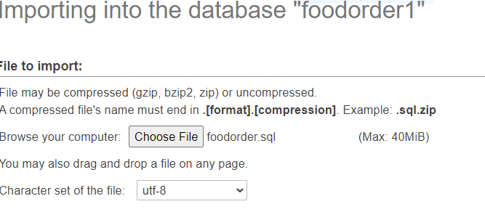

1. This will complete the setup of your database and you are ready to go, database as:-

**USE CASE DIAGRAM**

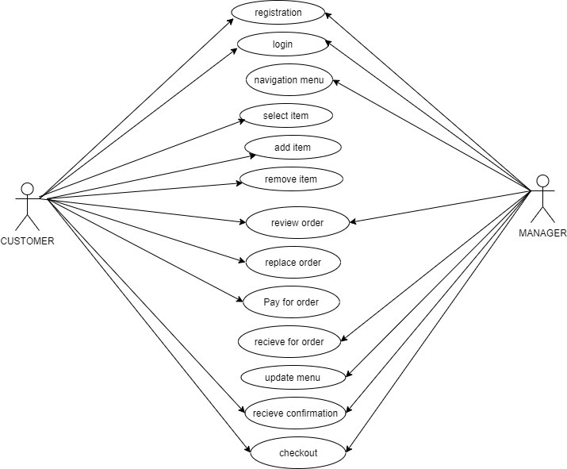

**ER DIAGRAM**

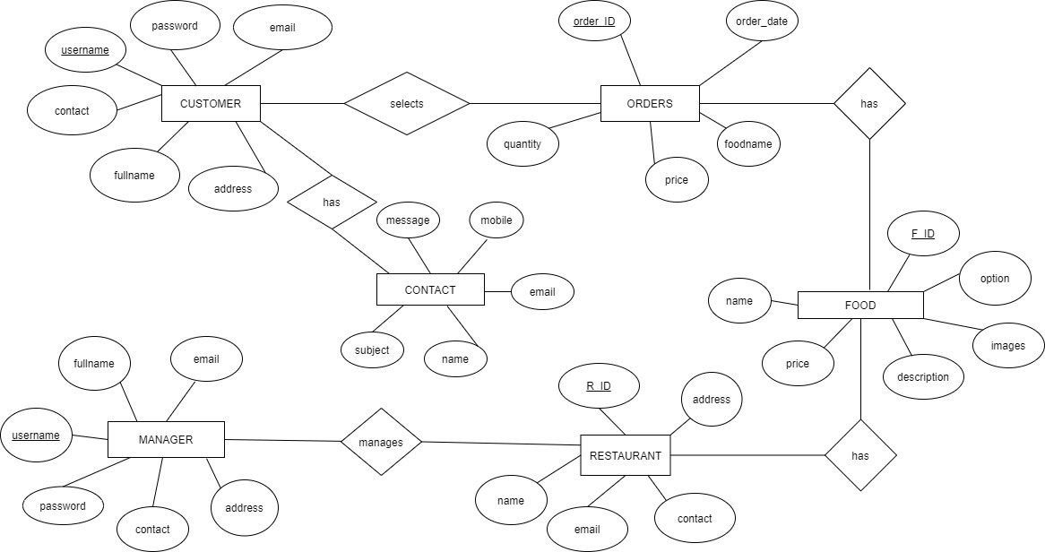

**IMPLEMENTATION**

Tech Stacks used:-

FRONT END:

1. HTML5
2. CSS3
3. Javascript
4. Bootstrap

BACK END:

* PHP
* XAMPP Server
* MySQL database and PHP programming language.

  Few images of our website

1. Home page-Navbar and Logo.

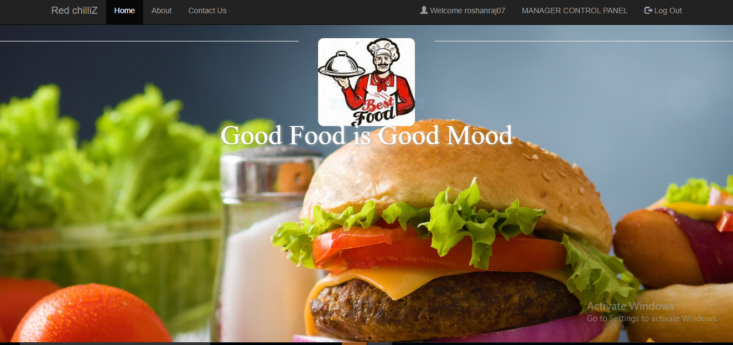

**=**Home Footer with glyphicons and chevron-up arrow mark

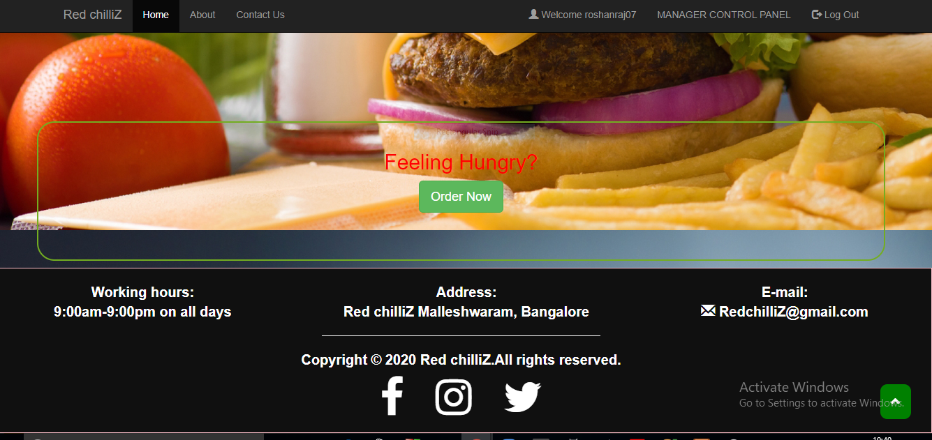

1. About with location on map

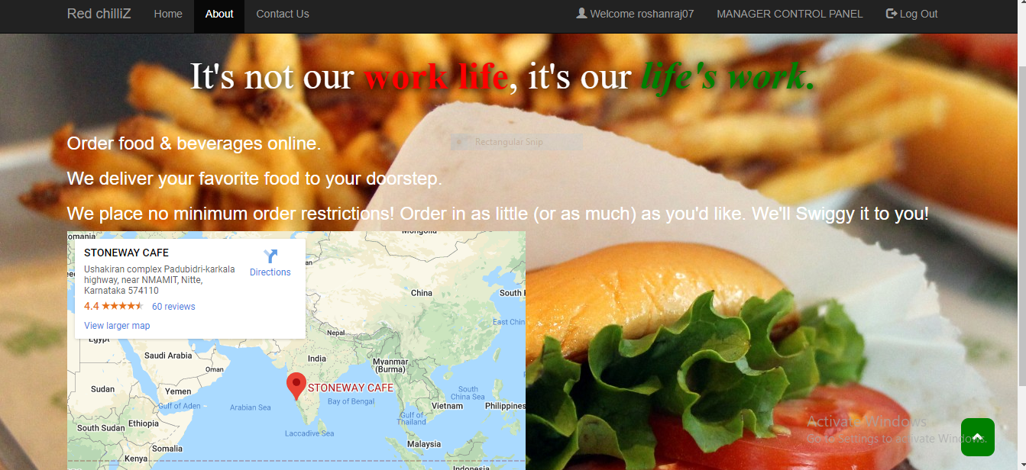

1. User login Page

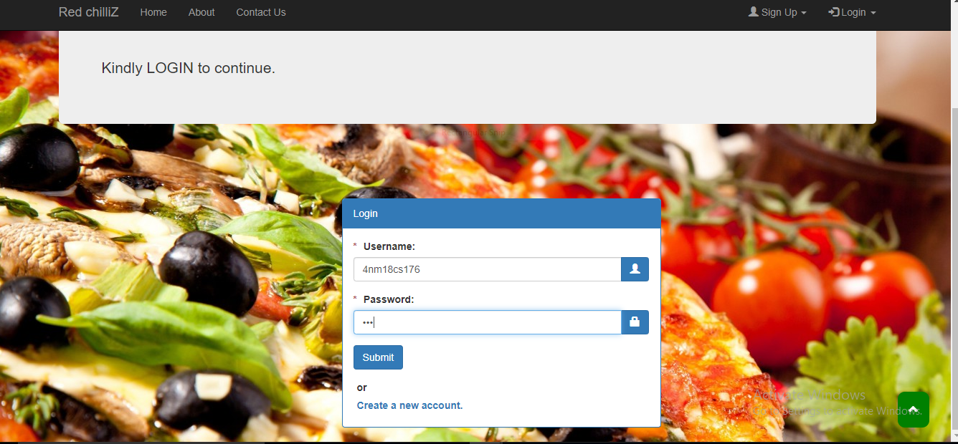

1. User’s Home Page after logging in.

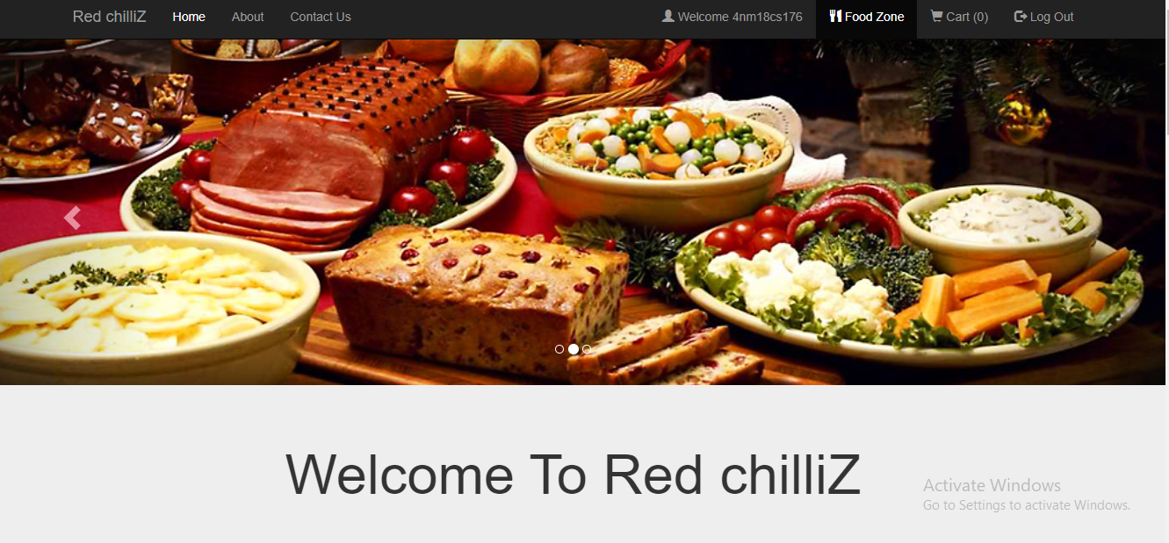

1. Food list view to order food items.

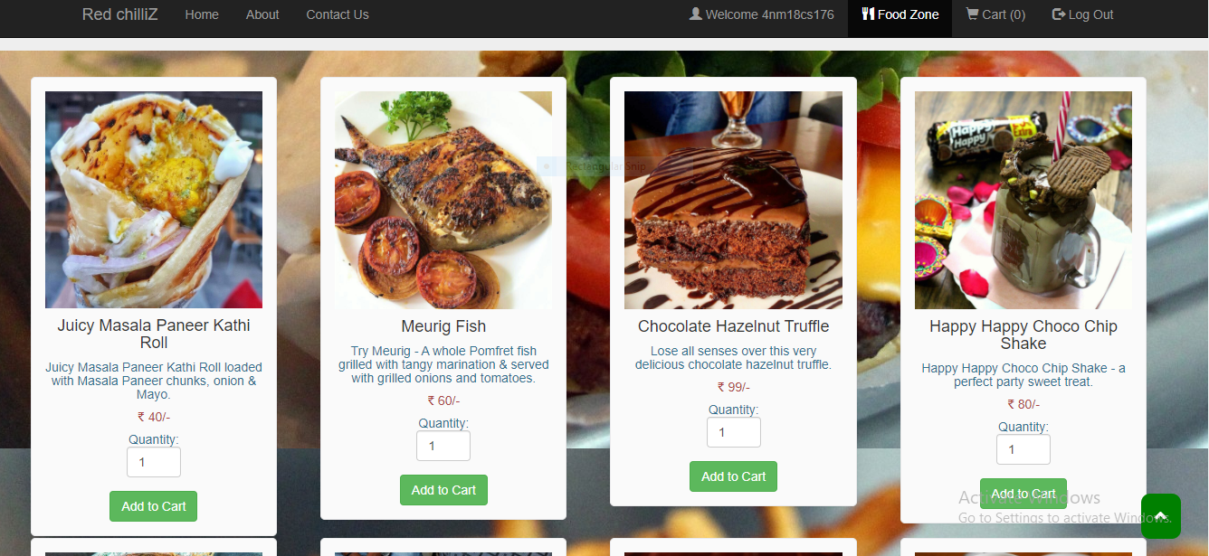

7) Food ordering  Cart ready to be updated with respective quantities ,amount to be paid ,or even empty the cart and checkout for payment.

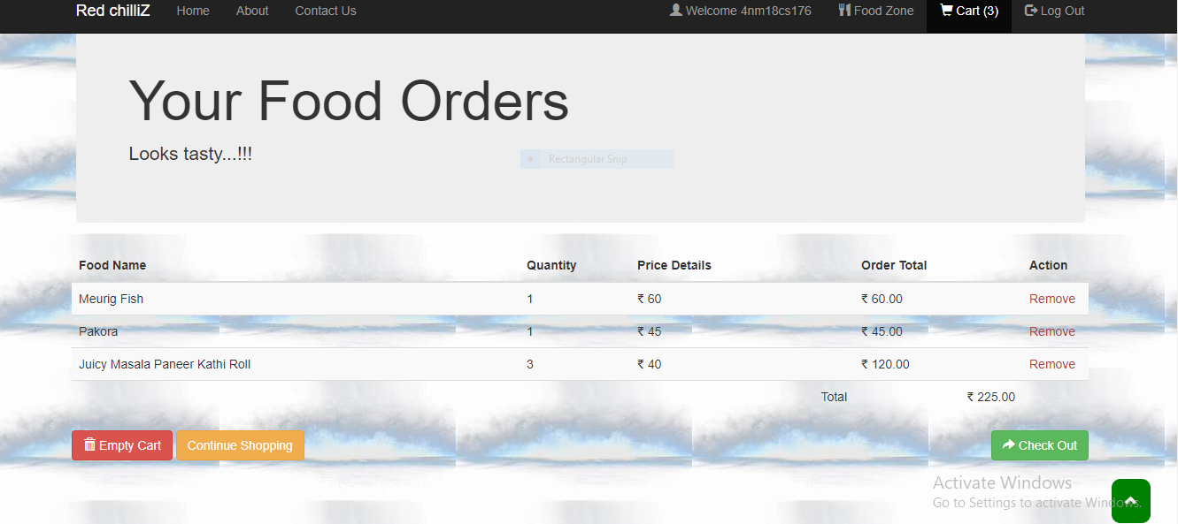

8) Payment options-Cash and Online Payment Option or going back to the cart.

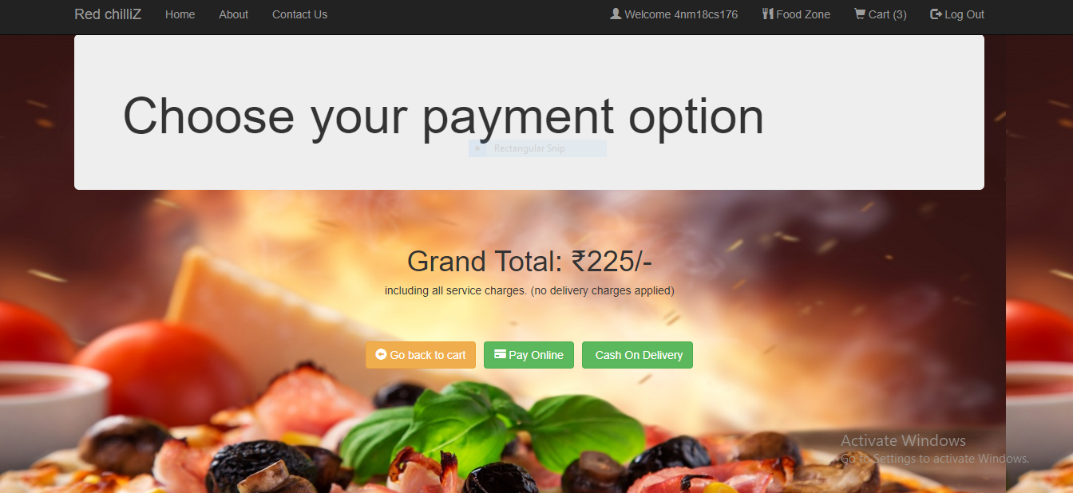

9) Order placed details with 18 digit order ID.

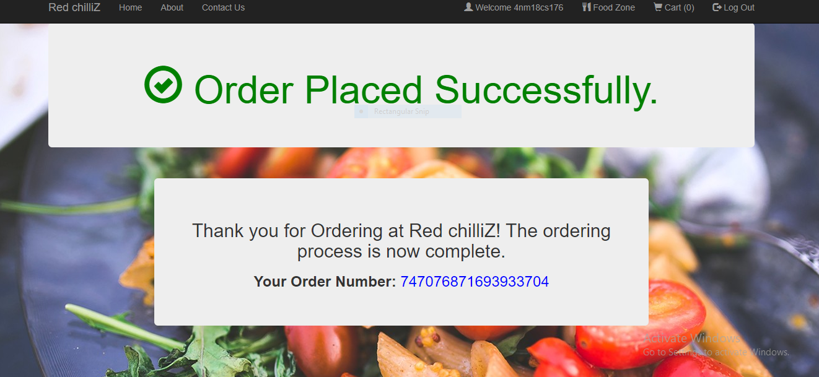

(Manager registration UI is similar to User registration).

10) Manager login

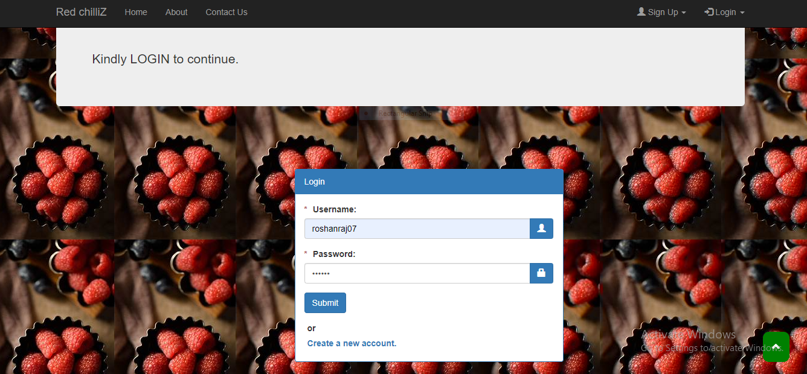

11) Manger my_restaurant Details

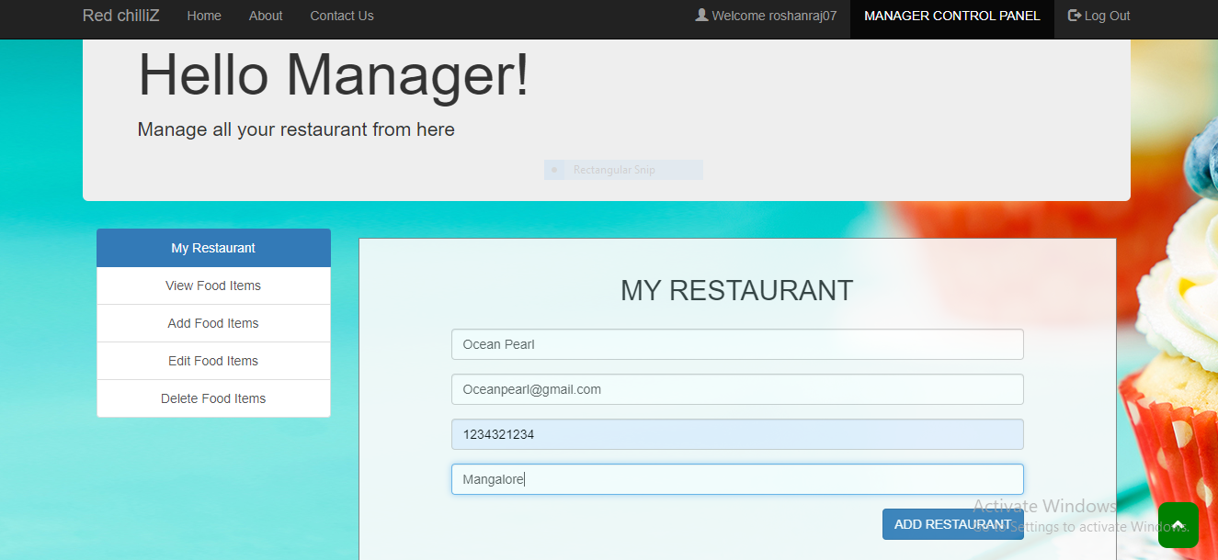

12) Food items edit

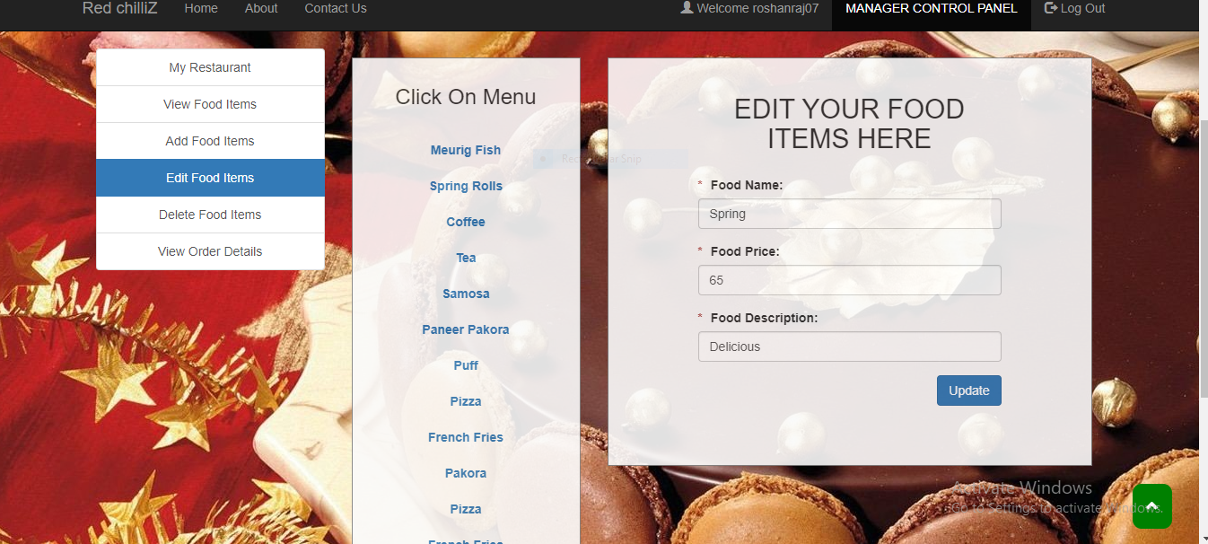

13) Add new food

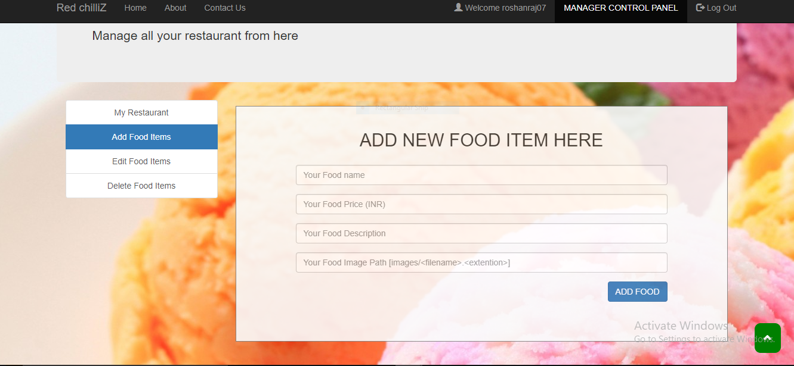

14) Managers can delete food items.

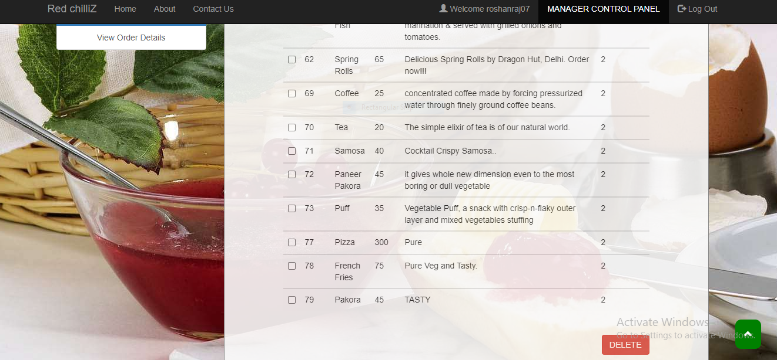

15) Food ordered list

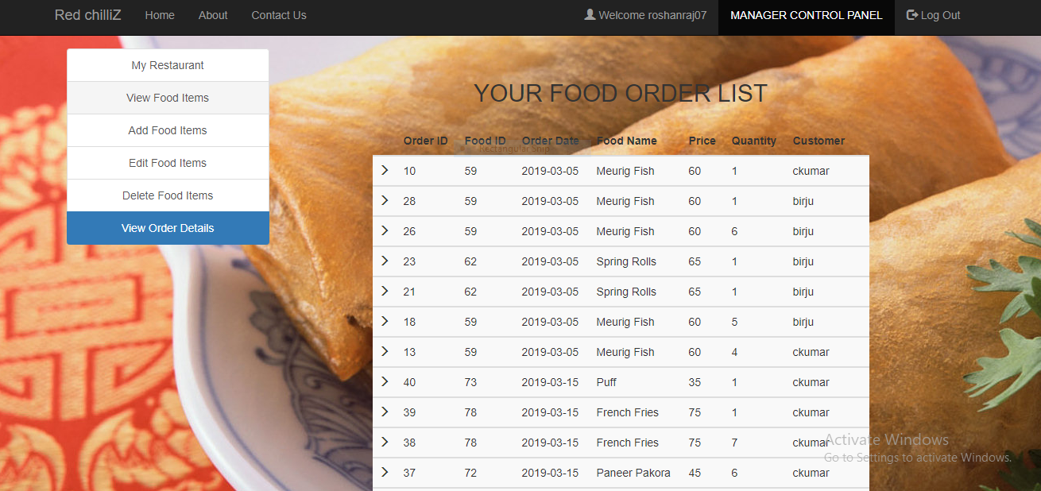

**RESULT AND DISCUSSION**

* The result of our system application includes a Web-based food ordering application.